RobotLab3 Exercises

1. clearBoard()

Pre-condition: The robot is in the top left corner of a 2D arena of randomly light and dark

squares, facing east. There are no bricks in the arena. The dimensions of the arena are

unknown.

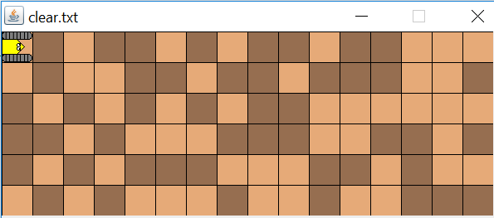

Post-condition: The robot has made all squares light, is at the top left corner facing east.

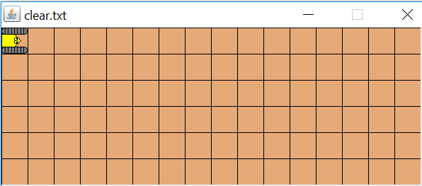

Test your solution on clear1.txt and clear2.txt.

1. connectDots()

Pre-condition: The robot is in an arena like the one below. The first dot will be two squares in front of the robot to begin. There will be at most two dots within any dot.

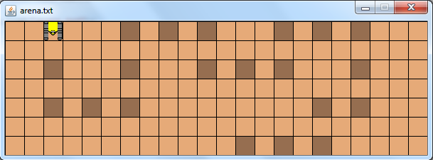

Post-condition: The robot will have connected the dots:

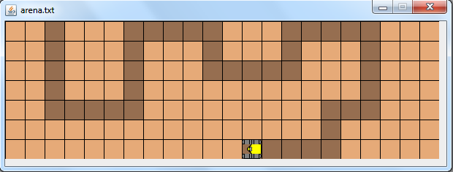

Test your solution on dots1.txt and dots2.txt.

1. maze()

Pre-condition: The robot is facing the start of a maze of bricks, with a dark square as the goal:

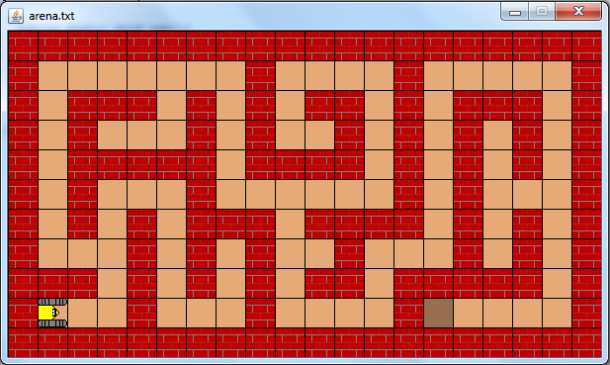

Post-condition: The robot has stopped at the dark square:

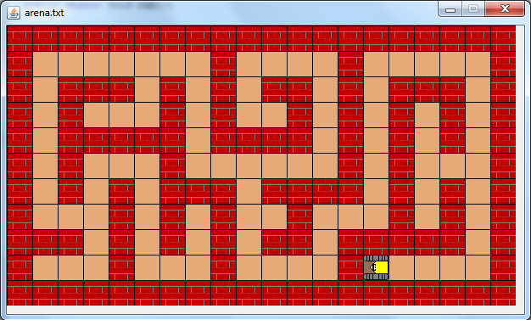

Test your solution on maze1.txt and maze2.txt. (To be added to GC later)

1. sort() CHALLENGE: EXTRA CREDIT

Pre-condition: The robot is in the top left corner of a rectangular arena facing east. The columns of the arena are darkened to form a histogram. The heights of the columns are in random order, as seen below.

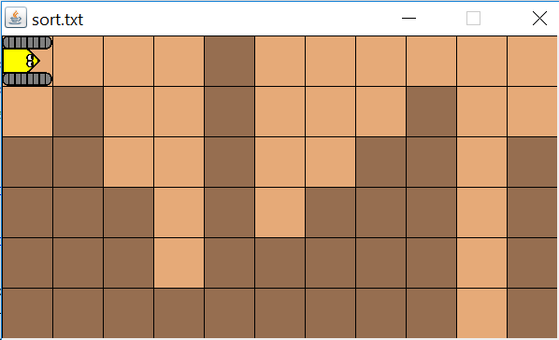

Post-condition: The robot is in the top left corner of the arena facing east. The columns have been sorted in ascending order.

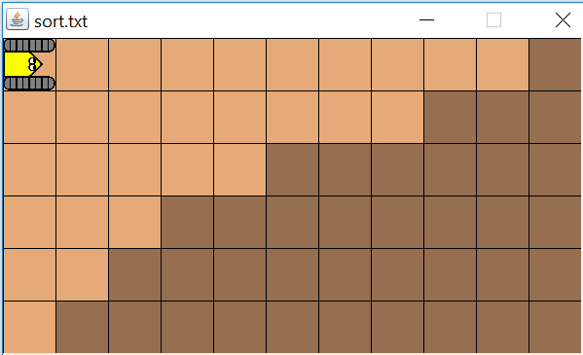

Test your solution on sort1.txt and sort2.txt.